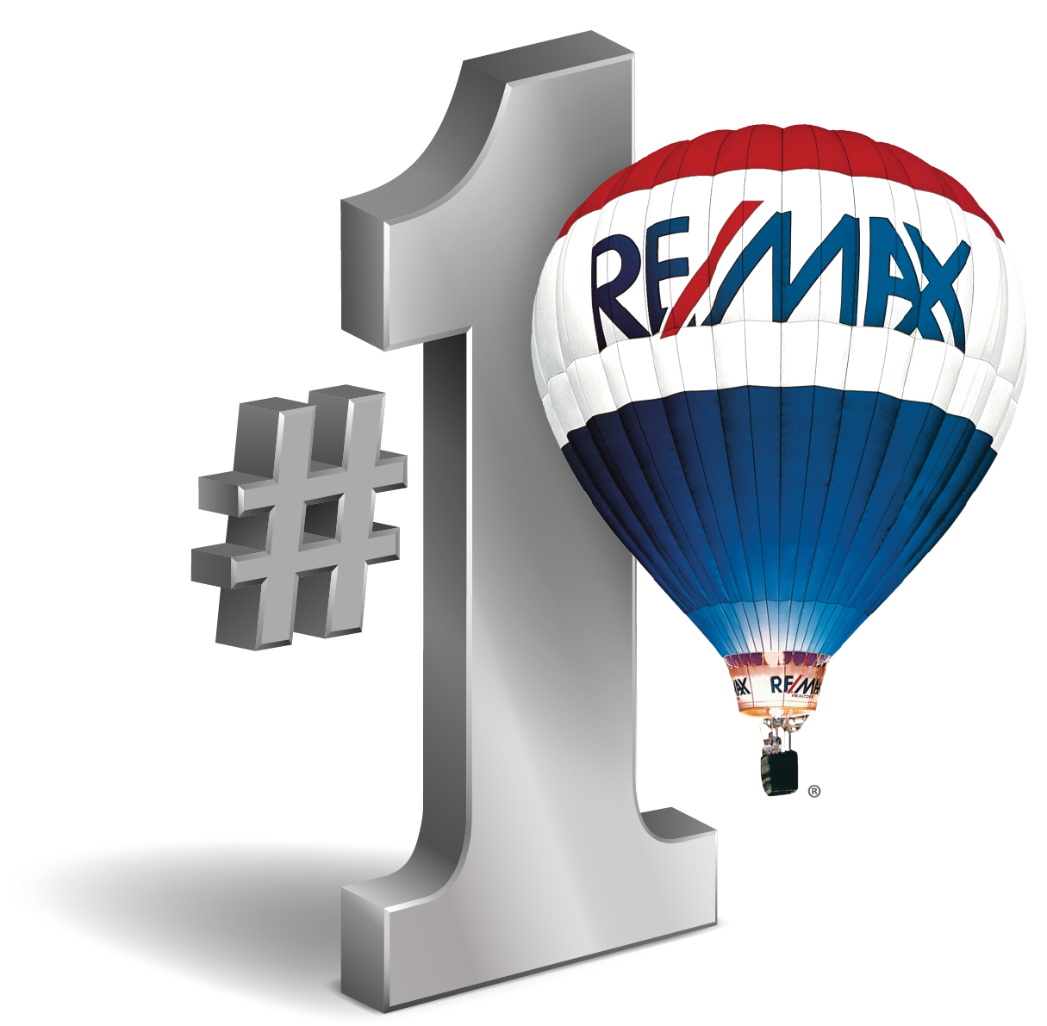
100, Riverside
1762 SW St Lucie West Blvd
Port St Lucie FL 34986
Ph: 772-785-6539 1-866-4 we list WWW.REALESTATE-PORTSTLUCIE.COM
Fax: 877-414-6597 BILL.EGGELING@REMAX.NET

MY PLEDGE TO YOU:

- To communicate with you at least once a week in person, by phone or by email.

- Keep you informed of all showings of your property

- Showcase your home on ZILLOW.com as well as feature your home on our websites.

- Conduct open houses upon request

- Present only qualified buyers with written offers

- Provide the best professional servicing available to market your home

- Provide assistance and updates during the closing process

- Be present at your closing

- NEVER charge you any additional transaction fees

I thank you for the opportunity to work with you and successfully market and sell your home. RE/MAX 100 RIVERSIDE values your business!

William Eggeling
______________________________________________________
Listing Agent, William Eggeling date

If you are not satisfied with our representation, simply provide your written concerns and allow 7 days to remedy the situation. If we are unsuccessful, you may cancel our agreement at no charge!

