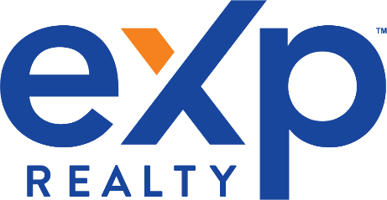

Not Your Typical Realtor.
Not Your Typical Realtor Bio.

You loathe typical real estate agent bios. Don’t worry, I do too. They’re like cardboard – stiff, bland, and identical to every other bio out there. Instead of boasting ad nauseum about awards and accomplishments you’re not interested in, I’m taking the novel approach of actually giving you what you want – real answers to questions you’re probably wondering right now.

Will you return my calls and emails?
Yes. Without question.
I realize this is one of the major frustrations the general public has with dealing with agents. I get dozens of calls and emails daily, and I work hard to reply as quickly as possible. If you call, text or email me within the hours of 7am to 8pm you will hear back from me promptly that same day.

I’ve met many Realtors who are jerks. Are you?
Depends on who you ask. If you ask certain agents who have stood between my clients and their real estate goals, they’ll probably say “yes”. A handful of people think I leave golden footprints in the sand. Those are the two extremes, and most people’s opinion fall somewhere in the middle.

Here’s what I can tell you:

I’m honest and candid. I take pride in being approachable and friendly. And if you need a quick real estate brain, or a strong dose of honesty, you’re in the right place. Loyalty to family, clients and friends is one of my core values including, AUTHENTICITY, INTEGRITY AND TRANSPARENCY.

Do you have experience doing exactly what I need?
Until you tell me what you need, there is no way of knowing.

These are “strong suits” of mine:
Negotiating
Working with expired listings
Relocation
First time home buyers
Military
Waterfront/Beach properties
Working with seniors and active adults

If your goal or situation isn’t represented on this list, don’t worry. Contact me anyway. If I can’t help, I can get you referred to another agent who can.

Michelle L. Mayo, REALTOR, ABR, SRES, SRS, RENE
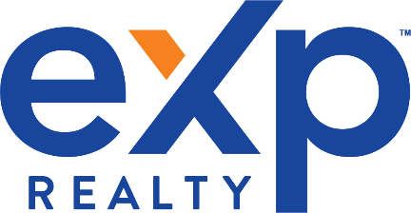

What kind of work are you really good at?
On a personal level, I’m pretty good at organization, cleaning and keeping a tidy home. Oh and I’m a pretty great mom too…….if I do say so myself. My kids have always been my first priority in life. They are my PURPOSE and my WHY for doing what I do.

On a professional level, here are the skill-sets that I’ve developed over the years:
Listening. Unfortunately, it’s a lost art these days.
Organization. I am super vigilant about not missing dates and deadlines. Think you won’t remember one, don’t worry, I’ve got you covered.
Negotiating. I do not back down from an attack agent and I am not easily intimidated.

What do clients think of you?
My clients are better suited to answer this for you. But see the attached list of testimonials from some of my past clients.

Quick Snapshot
Certified Probate Specialist
RE/MAX Top 25
7 year continuous 5 Star Real Estate Agent for Connecticut Magazine
Eastern Connecticut Association of Realtors Circle of Excellence Award
RE/MAX 100% Club
Accredited Buyer’s Representative (ABR)
Seniors Real Estate Specialist (SRES)
Sellers Representative Specialist (SRS)
Real Estate Negotiation Expert (RENE)
Military Relocation Specialist
Successfully hosted and ran a Toy Drive for kids in need

Michelle L. Mayo, ABR, SRES, SRS,RENE
eXp Realty of CT
michelle@shorelinehomesgirl.com
(860)514-9533

