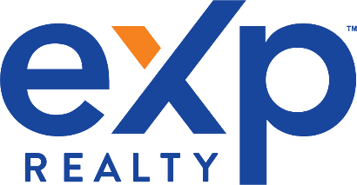

My name is Michelle Mayo and I am a local REALTOR. As a resident of Connecticut I specialize in home sales in and around New London and Middlesex Counties. I have given thought about what I would like to know if I were looking for a reliable and trustworthy REALTOR and I would like to provide you with a few reasons why I should be your Real Estate Professional:
- I am hardworking, honest and experienced
- I have a very strong work ethic
- I have excellent follow-up and follow-through skills
- I will always call/email you back promptly.
- I love my job and I am great at it!
- I will represent YOUR interests.....even if that means walking away from a transaction
- I will answer any of your questions/concerns with absolute honesty
- I will always tell you the truth...not just what you want to hear
- I will not disappear once a property goes under contract
- I will not disappear after it closes....I will be there with you from beginning to end and beyond
- I will be on top of any and all issues in our transaction
- I am very good at problem solving
- I will take responsibility for my mistakes, if any
- I am a professional; I will treat you and everyone involved with professionalism
- I have over 20 years experience in the industry.
I want your business and will do what it takes to earn it! I can promise that you will feel well- represented if you decide to use me as your REALTOR.
When you’re ready, I want to be your real estate agent. Feel free to contact me anytime on my direct line at (860)514-9533.
Your friendly Realtor,

Michelle L. Mayo
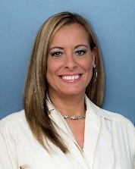

Michelle@shorelinehomesgirl.com, www.shorelinehomesgirl.com

