WHY DO BUSINESS WITH US?
We know our business.
We know where to find buyers.
We know how to make things happen.
We know how to negotiate contracts and real estate transactions.
We know Real Estate laws, practices, and principles.
We manage the process of dealing with all professionals in the transaction process from home inspectors, contractors, lawyers, etc.
We are full-time Real Estate professionals.
We provide a Customer Service Guarantee
If you’re not satisfied with our performance, call Ed Kozak, Vice President, directly at 508-737-1675

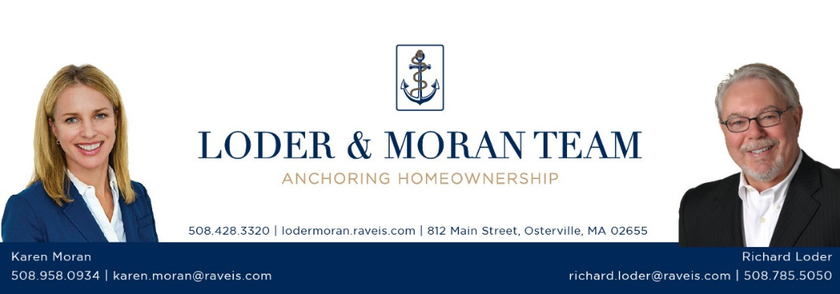

Professionals We May Work with
on Your Behalf

Attorneys:
  - Seller, Buyer, Closing, Estate, Bankruptcy, Relocation Company, Debt Services, Foreclosure

Inspectors:
  - Home, Septic, Well, Pest, Mold, Radon, Basement Water, Home Warranty

Contractors:
- Carpentry, Siding, Roofing, Waterproofing, Masons, Plumbing, Electrical, Air Conditioning, Furnace, landscapers

Mortgage Professionals:
  - Loan Officer, Processor, Title Company, Dept Services, Bank Rep for Short Sales, Foreclosure, Appraiser

Municipalities:
  - Town Hall, Board of Health, Assessor, Zoning, Public Works, Water Department, Fire Department

Seller/Buyer:
  - Agents, Builders, Stagers, Tenants, Appointment Coordinators, Condo Management Company, Locksmith, Sign Person, Engineer, Contractor Relocation Company

