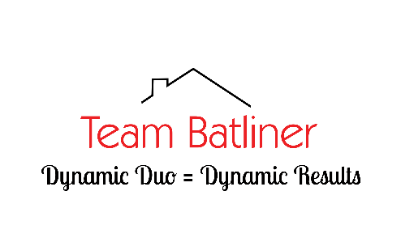
Referrals/testimonials

Whoa!....this was the most outstanding service that we have received from any agent. We were pondering selling our Florida property and moving to the mountains of North Carolina....asked John and Cindy to see what they thought was a reasonable sale price and decided to list the property.....SOLD WITHIN 24 HRS! Great agents who were side by side with us through whole process....but even more importantly great friends.
-Scott & Ellen

Down to earth fantastic people who’d give the shirts off their backs because that’s just the way they are. Best selling experience I’ve ever had.
-Jay

John and Cindy really know the area of housing they focus on. They do a great job from start to finish. We would recommend them over anyone in the area. Thank you for becoming a friend.
-Russ and Brenda

I have worked with a lot of real estate people in the last 40 yrs, but by far John & Cindy were the best
- very professional
-worked for me and not just a sale
-provided weekly updates
-advertised in the very best way
-helped with title company
-helped with the move
I will always recommend John & Cindy to all my friends and neighbors
-Glen and Cindy

The website connected us to John and Cindy which turned out to be a stroke of luck for us. We found the house of our dreams and John and Cindy continue to be extremely helpful and responsive. My wife and I feel that they go above and beyond.
-Dennis and Susan

John & Cindy provide outstanding service. They are with you, literally, from listing to closing and beyond. They enjoy their work and make you feel like family. They are "Can Do" people.
-Fred & Martha

