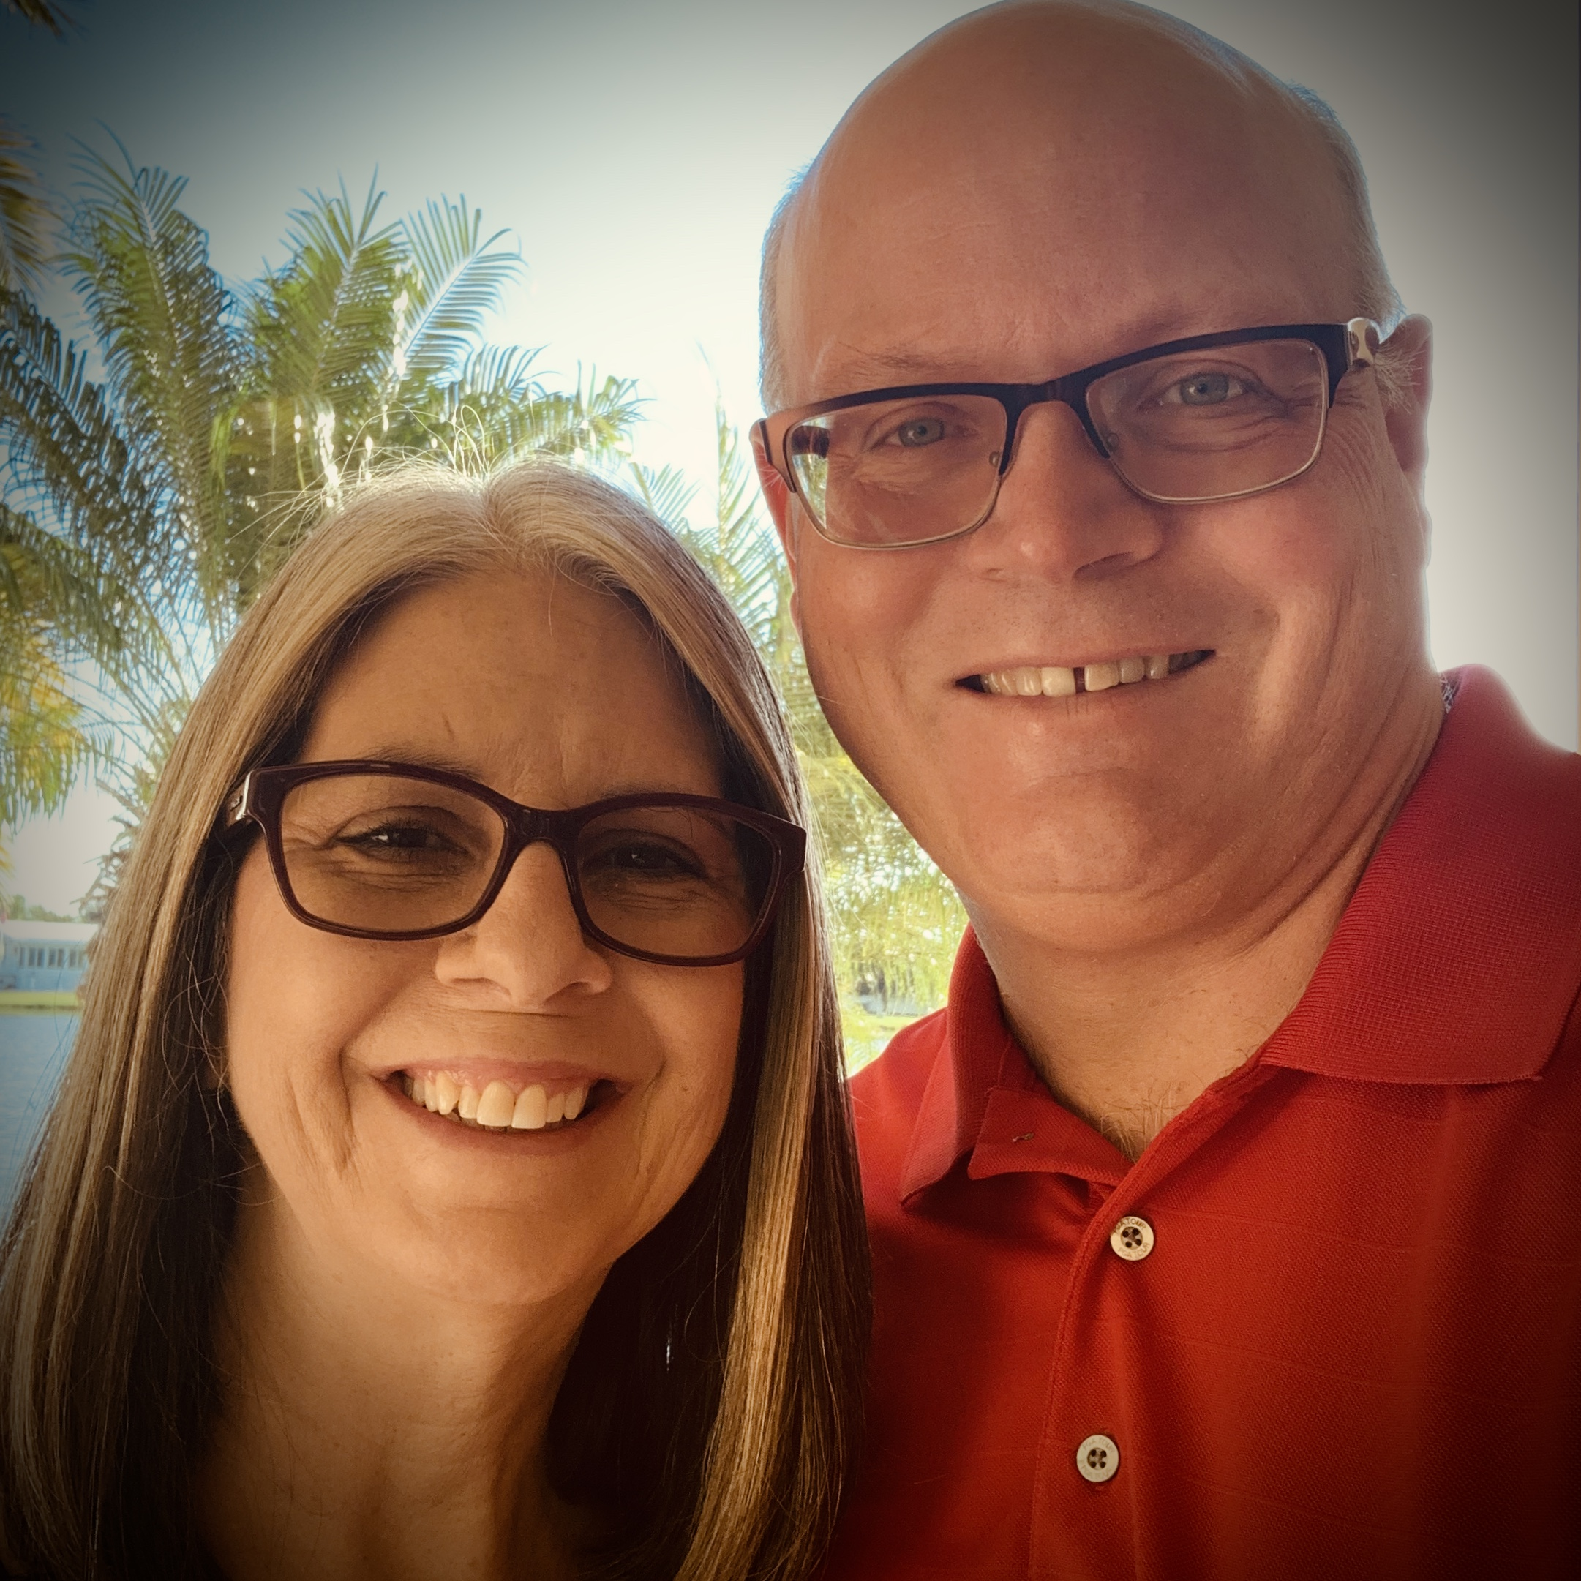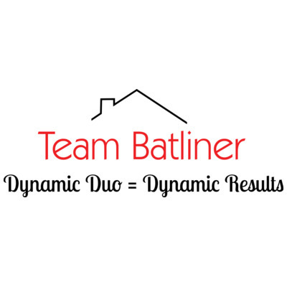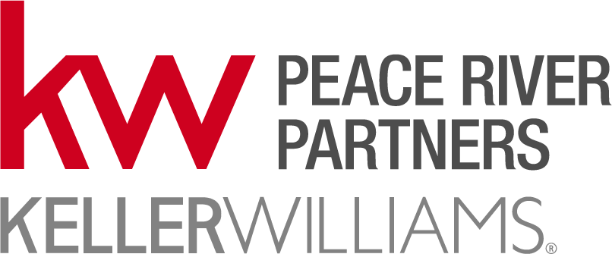 |  |  |  | John and Cindy  Team Batliner 10-point marketing plan
- We hire the best professional photographer we know. Your home will look great and stand out online.
- We pay for drone photo’s – people love the aerial view and it helps differentiate the house online.
- We pay for 3D video walk through – this gives buyers a perspective of being in the home. This has already led to people buying without ever being inside the home.
- We pay for drone video – highlighting the home and the community.
- Paid Facebook video – just listed campaign.
- Paid Facebook video – open house campaign.
- Promoted internally to KW internal facebook group – 190 agents!!
- Become part of our move to SW Florida promo campaign – marketed to several cities up north.
- We will host multiple open houses – at least one per month if that fits your schedule.
- Photo collage with “LARGE TEXT” customer synopsis.

Why Team Batliner
- Excellent negotiators
- Focused on gated communities
- Can add personal touch – if you’re selling your home while away – we can make sure home looks fresh for any showings that day
- As a team – you have two agents instead of one. This means more open houses, more focus, faster results.
- Wider skill set – as husband/wife team one or both of us will connect with other buyers/sellers.
- Extensive marketing campaigns currently running on Zillow, Facebook, and direct mail.
- We invest in the best photography/drone photo’s/drone video – it will make your house stand out online.
#1 in Florida
#1 in Charlotte County

John’s cell
941-585-7573
Cindy’s cell
941-585-7570
 |  | batcave@kw.com

