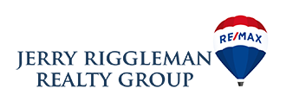

OUR MISSION STATEMENT:

We provide the most professional, informative, loyal and dedicated service within the real estate industry. The best interests of our clients will always come first, as we are dedicated to the development of long-term client relationships!