Preparing Your Home for Photograher
Front & Back Yard
* Clear front yard of Debris
* Weed and Mow lawn
* Edge Yard and Driveway
* Remove Vehicles From
Driveway and front
* Remove Trash cans if visible
* Powerwash mildew from driveway
and sidewalks
* Trim shrubs and trees
* Repair Windows – screens
* Hoses rolled up
* Pool sweeper Stowed away-
no hoses in pool
* Clean siding
* Make path to Front Door Clear
* Clean Front door-replace old hardware

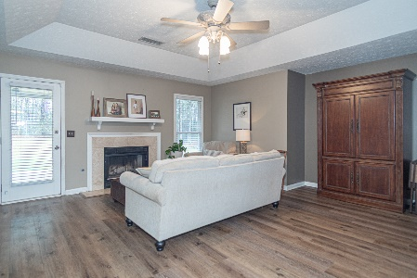
Main Living & Dining Areas
* Remove Clutter – remotes, game
Consoles, CD’s/DVD’s, etc.
* Remove family/personal photos
* Clean Fireplace
* Polish wood furnishings
* Remove worn rugs
* Fluff couch pillows

Prior to photo session, please have ALL lights and lamps turned ON. Replace all burned out lights and all ceiling fans OFF. Photographer does not move furniture or other items.

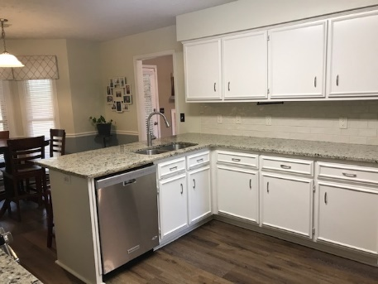
Kitchen

* Clean all Stainless Steel appliances
* Remove items off Refrigerator-
Magnets, etc.
* Clean stove hood
* Clear and clean countertops
* Remove towels from racks
* Hide sponges and soaps
* Remove rugs
*Remove small appliances off counters

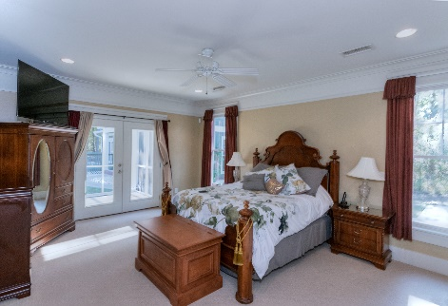

Bedrooms / Bathrooms

* Make bed
* Clean room
* Remove clutter in room
* Remove Personal items- Photos
* Clean Mirrors/shower door
* Toilet seats down
* Remove items on Bathroom countertops
* Remove items from shower
* Remove towels if old and worn

All property is photographed AS-IS. Anything you do not want photographed should be removed prior to appointment. Please keep Children and Pets away during shooting.

