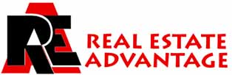

Rick & Julia McMahon
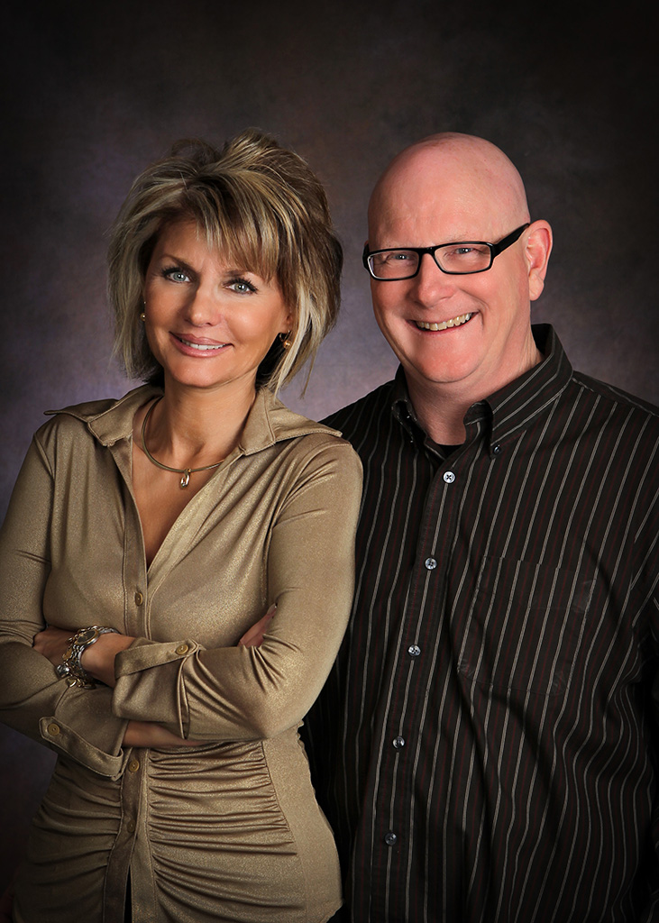

716-483-3300
rickandjuliarealtors@yahoo.com

EXPERIENCE

Assisted 1,411 families with the purchase or sale of a home we can help you too.

Voted Realtor of the Year and Voted Twice, Associate Realtors of the Year by the Chautauqua County Board of Realtors.

Consistently in the top 10% for production of Realtors nationwide.

Top 3% of Realtors in Chautauqua County out of 349 members.

EDUCATION

Updating continually our skills in Sales, Marketing, Internet Technology, Financing and Real Estate Law.

PROFESSIONAL AFFILIATIONS

Associate Brokers and Partners in Real Estate Advantage.
Members in good standing Chautauqua/Cattaraugus County Board of Realtors.
NY State Association of Realtors and National Association of Realtors.
Chairman MLS/Computer Committee, Director on Board of Directors.
Three Term President Chautauqua County Board of Realtors.
Member in Good Standing Lakewood, NY Kiwanis.
Member in Good Standing Holiday Valley Resort Safety Patrol.
For more info click on “About Us” on www.chautauqualakehomes.com
Zillow Reviews zillow.com/profile/Rick-and-Julia-McMah

