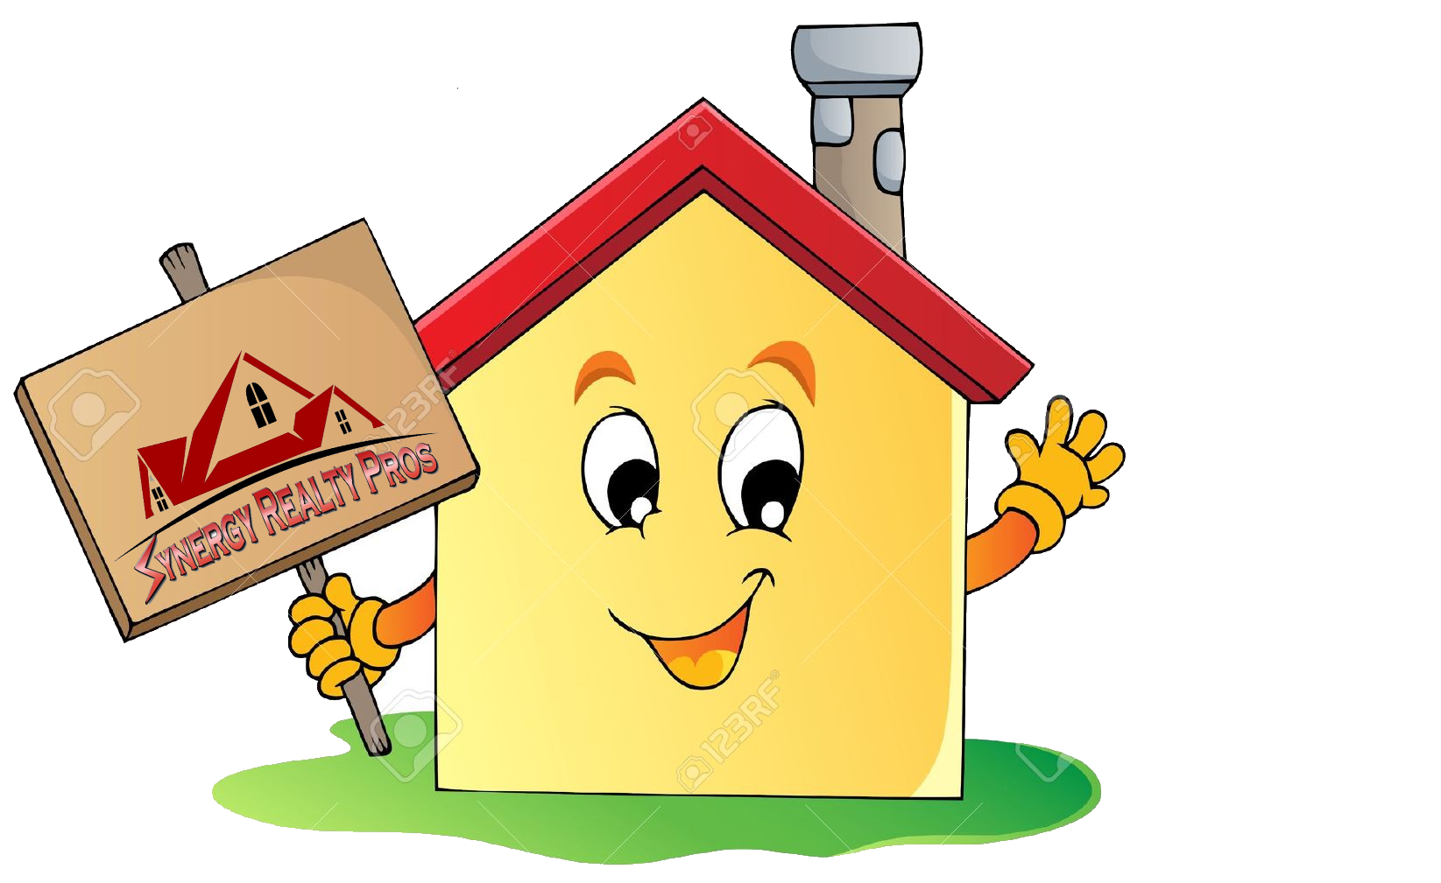  Harbor Crest  Unit 105B  Under Contract  in Less than 1 Week CALL ME  Sold BY  WE SPECIALIZE IN SELLING HOMES OTHERS HAVEN’T CALL US TO MAKE YOUR HOME A SOLD HOME | WE SPECIALIZE IN SELLING HOMES OTHERS HAVEN’T CALL US TO MAKE YOUR HOME A SOLD HOME  Harbor Crest  Unit 105B  Under Contract in  Less than 1 Week  CALL ME  SOLD BY
WE SPECIALIZE IN SELLING HOMES OTHERS HAVEN’T CALL US TO MAKE YOUR HOME A SOLD HOME  Harbor Crest  Unit 105B  Under Contract  in Less than 1 Week  CALL ME  SOLD BY  Your text here  S | WE SPECIALIZE IN SELLING HOMES OTHERS HAVEN’T CALL US TO MAKE YOUR HOME A SOLD HOME  SOLD BY  Your text here  HARBOR CREST  UNIT 105B  UNDER CONTRACT  IN LESS THAN 1 Week  CALL ME
SYNERGY REALTY PROS  3109 ZIMMERMANN STREET  WHITE PINE TN 37890  865 761 0105  NOT INTENDED TO SOLICIT HOMES CURRENTLY ONE THE MARKET | ________________________________________________________________________________________ | 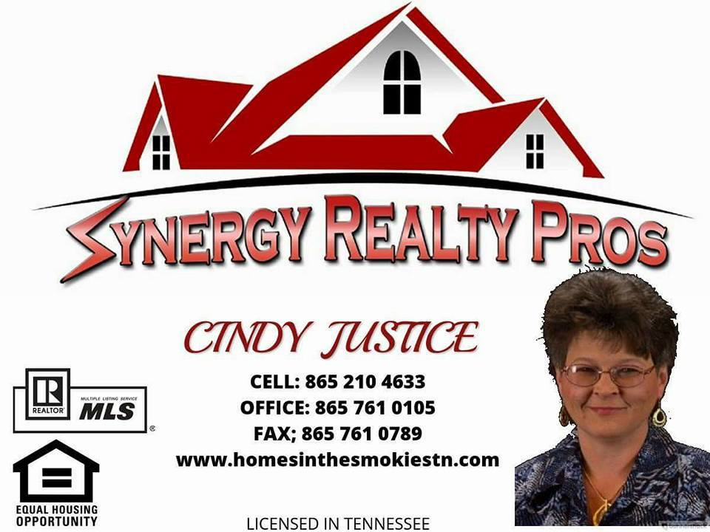  SYNERGY REALTY PROS  3109 ZIMMERMANN STREET  WHITE PINE TN 37890  865 761 0105  NOT INTENDED TO SOLICIT HOMES CURRENTLY ONE THE MARKET | ____________________________________________________________________________________________
SYNERGY REALTY PROS  NOT INTENDED TO SOLICIT HOMES CURRENTLY ONE THE MARKET  3109 ZIMMERMANN STREET  WHITE PINE TN 37890  865 761 0105 | ________________________________________________________________________________________ | SYNERGY REALTY PROS  3109 ZIMMERMANN STREET  WHITE PINE TN 37890  865 761 0105  NOT INTENDED TO SOLICIT HOMES CURRENTLY ONE THE MARKET | ____________________________________________________________________________________________

