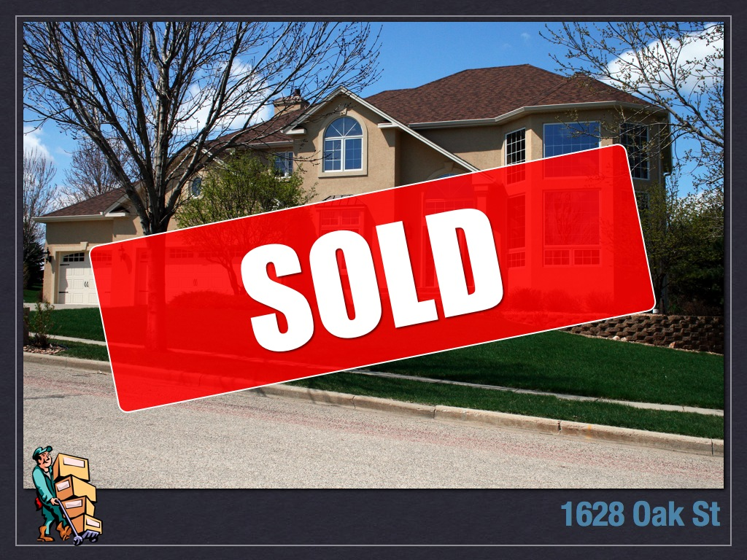
Marketing PLUS
Complete Real Estate Action Plan to Sell
Your House For the Highest Price Possible
Carol Ellis
CITY LIMITS REALTY, LLC



PHASE 1 – BEFORE WE LIST THE PROPERTY
- Research property’s ownership and deed type
- Research property’s public record information for lot size, dimensions, additions, permits and other data
- Research sales activity for past 6-18 months from the Multiple Listing Service and public record databases
- Research tax records
- Establish market price trends
- Establish square footage from tax records or appraisal
- Research “Average Days on Market” for property of this type, price range, and location
- Research competition properties that are currently on the market
- Research competitive properties that have sold in the recent past
- Research sales activity on your home (if previously listed)
- Prepare “Comparable Market Analysis” (CMA)
- Establish fair market value
- Verify Homeowner Association fees and other information, if applicable
- Review your time schedule
- Review your plans and goals
- Compile a list of the best property features and benefits
- Create a neighborhood information list (schools, shopping…)
- Review the basic marketing plan
- Review advanced marketing strategies
- Prepare showing instructions for other Realtors
- Present current market data
- Review competing properties currently for sale
- Evaluate recent sales
- Suggest the best listing price
- Determine the most likely sales range
- Prepare estimate of closing costs and fees
- Determine estimated net cash proceeds after the sale
- Review and complete the listing agreement
- Review and complete other contracts and applicable disclosures
- Upload listing documents to Transaction Desk in MLS
- Install secure lock box system
- Install professional For Sale sign
- Install QR code scan and link to property site
- Have professional photos taken
- Have video filmed and add to YouTube channel
- Prepare a full-color property information sheet
- Add listing to current print media marketing


PHASE 2 – MARKETING AND PROMOTION
- Submit the property to Multiple Listing Service
- Mail you a copy of the MLS
- Register a custom web domain
- Build a Single Property website – include HD photos, video, property features and benefits, neighborhood information, schools, etc.
- Email you a property site link for review
- Register property for sellers home warranty
- Email property information to all potential buyers
- Launch direct mail campaign to potential buyers
- Mail Just Listed postcards to the area
- Submit property video to YouTube and other video sites
- Review all online marketing syndication channels, such as Google, Realtor.com, Zillow, Trulia, etc.
- Show property to all interested buyers
- Review all buyer comments and feedback
- Make changes and adjustments, if needed
- Contact you weekly with updates, results and feedback
- Review recent market changes and updates in the area

- Schedule an Open House, if applicable
- Complete a pre-open house marketing campaign
- Set up property before Open House
- Review Open House results and feedback
- Prepare and review monthly market update
- Make recommendations based on the latest data
- Email website view results weekly



PHASE 3 – SALE AND CLOSING
- Prequalify all potential buyers when possible
- Eliminate bargain-hunters and non-qualified buyers when possible
- Receive and review all Offers to Purchase contracts submitted by buyers or buyers’ agents
- Determine the best negotiating position
- Review all offers in detail with you
- Negotiate the highest price and the best terms on your behalf
- Have all purchase contracts signed by all parties and deliver or email you all copies
- Promptly record buyer’s earnest money deposit in escrow account
- Obtain buyer pre-qualification letter from lender at time of contract
- Provide buyer and/or buyer’s agent with all applicable contracts, disclosures and documents for signatures (may be electronic)
- Provide final copy of contract to all parties and lending institution
- Schedule and supervise all property inspections
- Review all inspection results with you and make suggestion regarding any repairs needed
- Change MLS status to “SALE PENDING”
- Contact the lender weekly to ensure timely loan processing
- Coordinate property appraisal
- Provide comparable sales data to lending institution
- Review the appraisal results with you
- Review property tax payoff and mortgage payoff through escrow
- Coordinate closing process with buyer agent and/or buyer
- Setup of power attorney, if applicable
- Schedule and supervise the final buyer walk-through inspection
- Update all closing forms, as needed
- Review any prorations such as HOA, utilities, etc.
- Confirm closing date and coordinate with all parties
- Request buyer’s home warranty be sent to closing attorney
- Request final closing figures from closing attorney
- Provide wire instructions for buyer or seller
- Provide deed additions, if necessary to closing attorney
- Handle any last-minute details
- Coordinate smooth closing on your behalf
- Arrange possession and transfer of ownership – keys, remotes, security codes, association keys, etc.
- Present you with your closing documents and final check or wire
- Respond to any follow up calls and inquiries after closing
- Provide cancellation of homeowners insurance and utilities

