It’s a New Year Loaded with New Journeys

As we roll into 2019, we are SO excited to tell you about all the wonderful New Happenings going on with The Kelly Corda Team: We’re transitioning to a New Company with New Opportunities …. And BEST OF ALL, our service to YOU is only going to get Better!

REALTY ONE GROUP RESTORE is a New Brokerage that the Kelly Corda Team now calls home. REALTY ONE GROUP (ROG) is the fastest growing Real Estate franchise in the country and has been for 7 years running! This company shares our goal of laser focused customer service. Their attention to detail with industry tools, personal coaching, and technology is unmatched in the industry. Our team is anxious to integrate these innovative and proven tools to help make the next step in your journey as valuable and stress free as possible.

This New Opportunity will allow us to improve our personal service to you as part of the larger ROG RESTORE team. Our new office in Collegeville is comprised of the area’s top agents with varied experiences and knowledge. While we may be moving to a new company, we are always mindful of our commitment to our clients and look forward to providing the exceptional service that you have come to expect.

The KELLY CORDA TEAM …
Kelly Corda, Kelly Fleischmann and Perry A Corda, Sr

Taking a Life Journey with our Clients

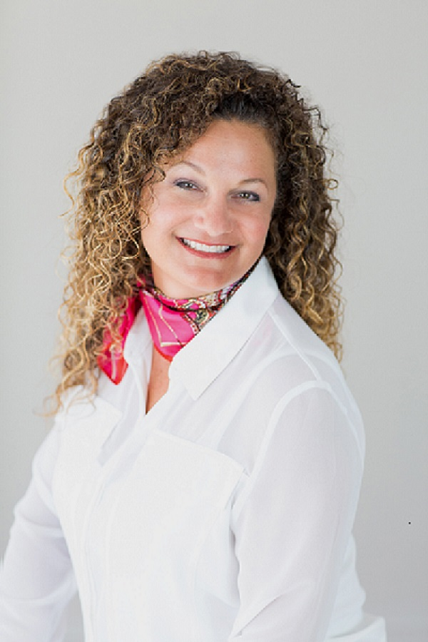
Meet the Team!
- Kelly Eason Corda: I bring over 12 years of Real Estate experience, having closed hundreds of homes, working with buyers, sellers, land acquisition, and relocation. I have earned the prestigious Certified Residential Specialist (CRS) designation which represents the top 3% of all REALTORS in the country. Mentoring has always been a passion for me and I’m excited to grow more as a leader for my team. Contact Info: 484-919-0681; KellyCordaTeam@gmail.com
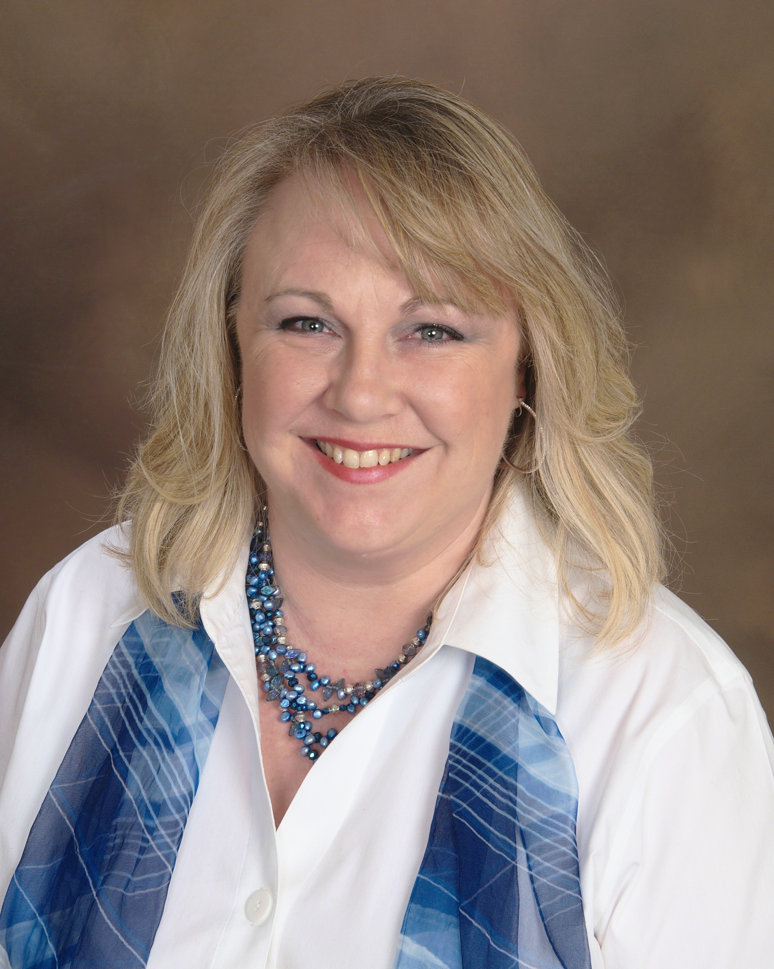
- Kelly Fleischman: Brings decades of real estate experience including investing, renovating, and Home Staging. In her first year, Kelly has proven to be the ethical, motivated, and quality agent I want on my team! She has become a valuable asset to the team and shares my customer service focused mantra. I simply love working with Kelly and I know you will too! Contact Info: 215-593-6224; KellyRealtyOne@gmail.com
- Perry A Corda Sr: My husband is jumping on board bringing 30 years of management and processing skills to make our team operate more efficiently and effectively. We feel that as a team we can ensure that our clients/friends/family have the most stress free, exciting and pleasurable real estate journey possible. Contact Info: 484-919-0682; PerryCorda@gmail.com

